RMNCAH ANALYTICAL REPORT
Comprehensive analysis of antenatal care and maternal mortality indicators.

Executive Summary
This report analyses RMNCAH performance using DHIS2 data. The analysis focuses on antenatal care continuity (CPN4 coverage) and Institutional Maternal Mortality Ratio (IMR).

Methodology
CPN4 rate = CPN4 et plus / CPN1 (1er contact) × 100
IMR = Décès maternels × 100000 / Acchmts en FOSA

CPN4 Performance
Year | Region | CPN4 Rate (%)
2024 | Region Nord-Ouest | 59.9
2024 | Region Sud-Ouest | 54.5
2024 | Region Nord | 47.2
2024 | Region Ouest | 45.8
2024 | Region Extreme-Nord | 45.4
2024 | Region Littoral | 45.2
2024 | Region Adamaoua | 44.3
2024 | Region Centre | 41.2
2024 | Region Est | 38.9
2024 | Region Sud | 36.4
2025 | Region Nord-Ouest | 60.4
2025 | Region Sud-Ouest | 52.6
2025 | Region Nord | 46.8
2025 | Region Littoral | 46.7
2025 | Region Ouest | 46.4
2025 | Region Extreme-Nord | 46.1
2025 | Region Centre | 42.6
2025 | Region Adamaoua | 40.9
2025 | Region Est | 39.4
2025 | Region Sud | 39.2
Interpretation:
- >80%: Excellent continuity of antenatal care.
- 60-80%: Moderate performance.
- <60%: Requires urgent intervention.
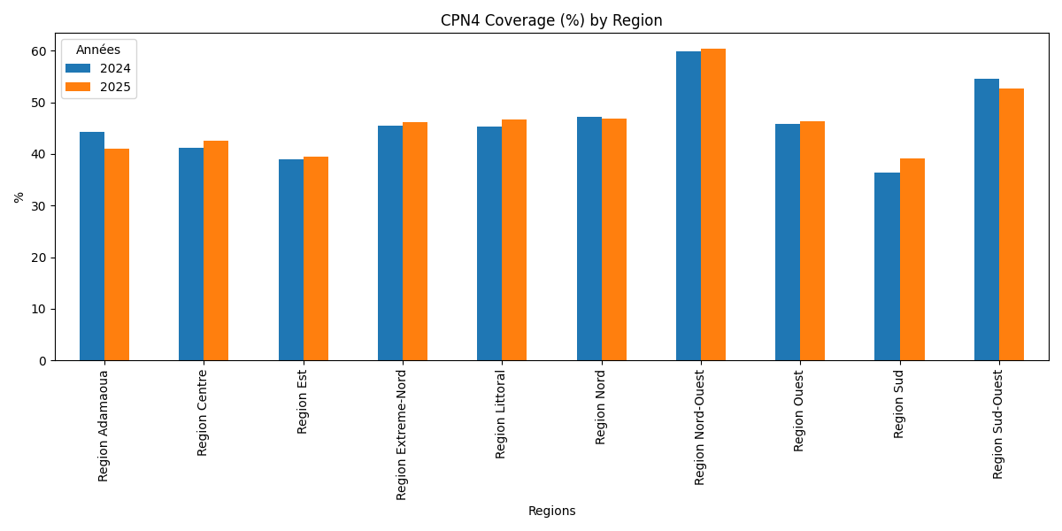

Institutional Maternal Mortality Ratio
Year | Region | IMR
2024 | Region Ouest | 98
2024 | Region Nord-Ouest | 107
2024 | Region Nord | 117
2024 | Region Centre | 126
2024 | Region Est | 137
2024 | Region Sud-Ouest | 145
2024 | Region Extreme-Nord | 161
2024 | Region Adamaoua | 170
2024 | Region Sud | 171
2024 | Region Littoral | 191
2025 | Region Centre | 75
2025 | Region Nord-Ouest | 76
2025 | Region Sud | 112
2025 | Region Ouest | 119
2025 | Region Nord | 120
2025 | Region Est | 131
2025 | Region Sud-Ouest | 175
2025 | Region Extreme-Nord | 187
2025 | Region Littoral | 259
2025 | Region Adamaoua | 294
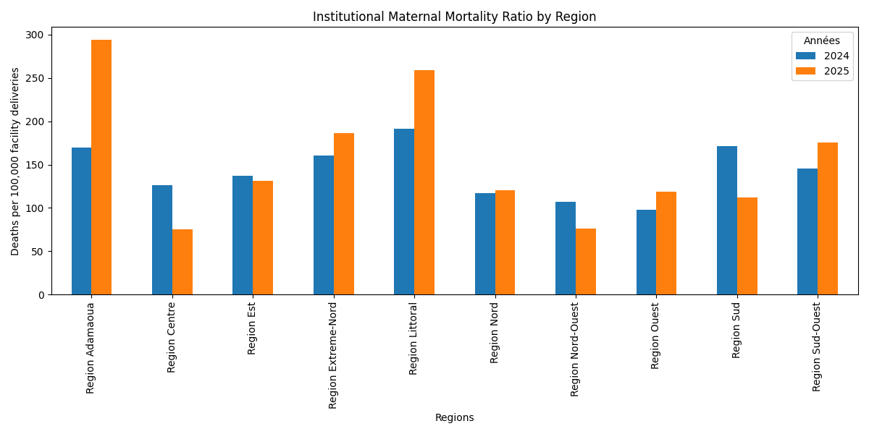

Facilities/Districts Requiring Attention
Highest IMR (priority areas):
- District Mbanga | CS St Albert le Grand : 300000
- District Nkolndongo | Fondation Le Bon Samaritain : 100000
- District Odza | (closed) CS Promotion de la SantÃ© : 50000
- District Logbaba | CS Universitaire du Golf (IUG) : 37500
- District New Bell | CS La Perseverence : 25000
Lowest IMR (best performers):
- District Mifi | Centre de SantÃ© LA PERFORMANCE : 0
- District Mifi | Cs APPROPRIN (Docta NZE) : 0
- District Mifi | Clinique la Riviera : 0
- District Mifi | Clinique de la Solidarite : 0
- District Mifi | Clinique Sos Ouest : 0

Recommendations
- Strengthen ANC follow-up to improve CPN4 completion.
- Target districts with low CPN4 rates.
- Investigate facilities with high IMR.
- Strengthen emergency obstetric care and referral systems.
- Improve maternal death surveillance and response.

